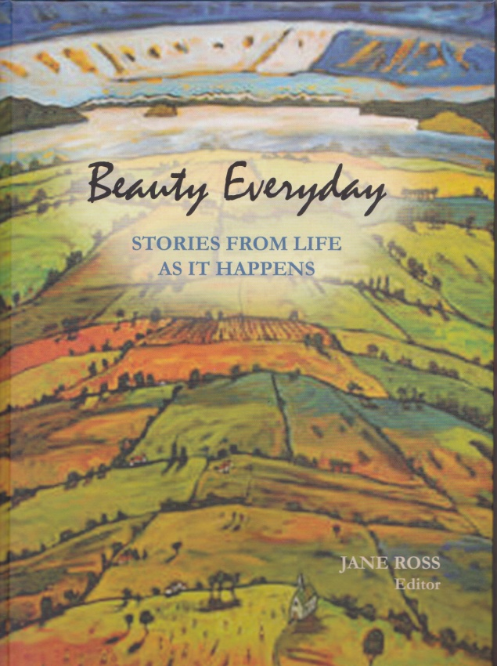
BOOK ORDER FORM
An anthology of stories by ALBERTA AUTHORS,
illustrated with designs,
photography and music inspired by
the regional landscape.
328 pages. Full colour.

For more information: Call Jane Ross 780/672-9315; or
Janet Enns 780/672-8177, or Email: source21@telus.net

Beauty Everyday: Stories from Life as it Happens
___________________________________________________________________________________
Yes. I would like to order ______ copies at $29.95 copy. ($15.00 Shipping extra) CASH/CHEQUE
Make cheques payable to: Battle River Writing Centre. Box 1581, Camrose, Alberta T4V 1X4
Name: _______________________________ Address: _________________________________
Email: _______________________________ Telephone: _______________________________
ENDORSEMENTS (a selection)
Each story offers a solution for positive change because the writers have been recognized and included in a new and important way. Wahkotowin. We need to work and live together.
―Dr. Wilton Littlechild, LLB. Representative to UN Permanent Forum on Indigenous Peoples. Honorary Chief, Maskwacis Cree; National Truth & Reconciliation Commission.
Beauty Everyday: Stories from Life as it Happens is a magical collection of accounts that chronicle the personal histories of real people who share the experience of living in Alberta’s Battle River Country. Spanning time and the globe, the descriptions of people’s lives are at once heartwarming and sad, inspiring and reflective. Captivating from the beginning, the stories speak to us from the past and provide encourage examples of how adversity can be overcome through the right channeling of the human spirit.
―Ron Sheppard... MA, MLIS. Director, Parkland Regional Library System, Lacombe, Alberta.

